 | 
NEWSLETTER
June 2019

PRESIDENTS REPORT

Hi Everyone- welcome to the first Club newsletter for the 2019/2020 Zonta year. Firstly, I would like to thank Rhonda for her wonderful leadership and commitment as the immediate past President. As the incoming President, I am looking forward to working with all of you for the next year to progress plans and continue our work in support all women in our community, especially those who are the most vunerable. The new committee structure should streamline our activities and help us focus our energies on achieving our objectives. I look forward to further discussion on this topic next meeting. Welcome to new Board members Carol and Rosemary.Thank you Rhonda for inducting the 2019/2020 Board members.
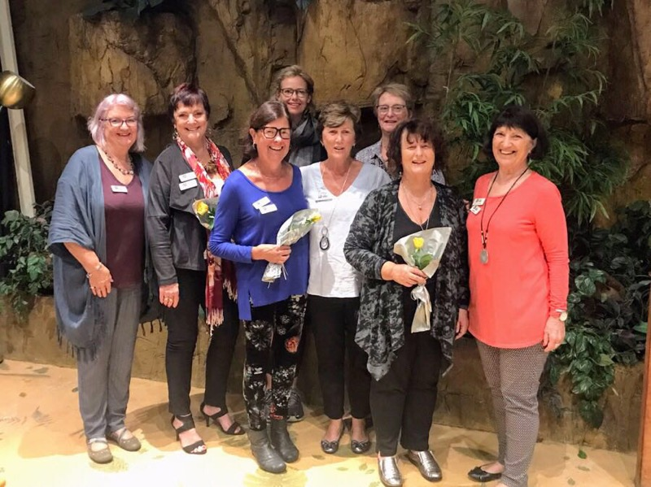
On another note, this is the first year that Merle has not served on the Board for many, many years. Her contribution to the club as President, office bearer and director has been outstanding. She is responsible for leading the breast cushion and drainage bag project, and for getting the women from Broadwater involved. Merle has a wide range of contacts in the Zonta world in Australia, and has used her friendships to the enhance the work of our club. Our sinsere and heartfelt thanks go to Merle for her outstanding contribution to the Zonta Club of Southern Gold Coast Tweed and to District 22 (and previously to District 24). We hope you will be contributing for many years to come.

Jess has resigned from the Board. She made a great contribution to the board this past year and her input will be missed. Jess will continue to contribute to our club projects in the upcoming year.

Margaret Alcocks presentation on neonatal nursing at GCUH and on the “Someone Who Cares” project in PNG was wonderful and created a lot of discussion. It is great that superceded medical equipment in Australia can be out to such good use in developing countries. The dedication of some people to bring about improvements for women in countries with such a lack of resources is so inspirational.
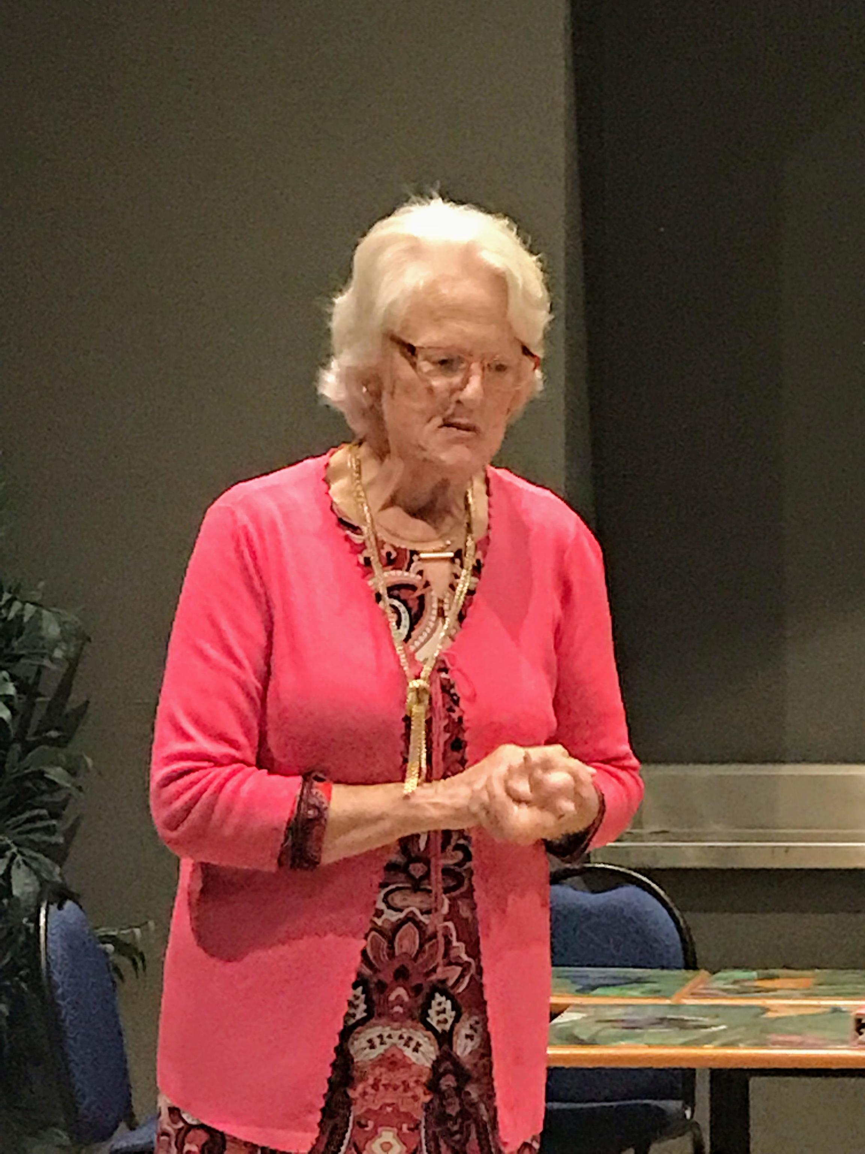
Louise and I attended the Area 3 Office bearers workshop on Saturday 1 June. The objective of this workshop was to introduce new and continuing Board office bearers to the legal framework for boards of incorporated entities, to bring attention to matters of governance, and to help board members have a full grasp of the roles and responsibilities of the various office bearers. I personally took a lot from this workshop and look forward to putting some of the ideas into place over the following months.

Breast Cushion Update

The lovely ladies at Broadwater have completed 42 breast cushions and that have now been delivered to the hospital. 10 lovely bags for sexual assualt packs were also made.

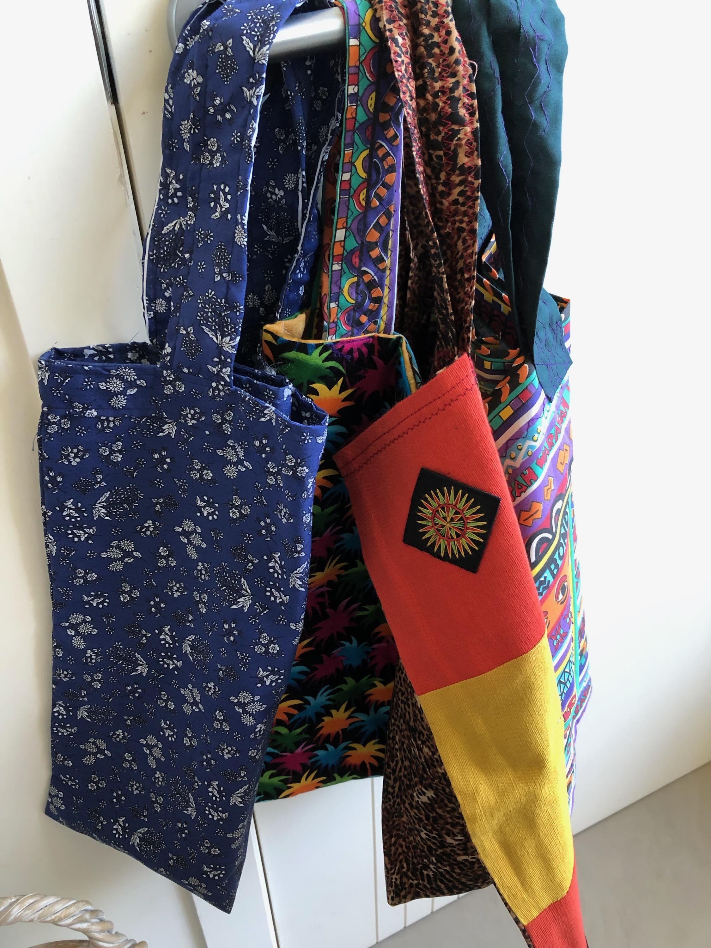

DATE CLAIMERS

    - ZCSGCT Board meeting – Tuesday 2 July 2019, Currumbin RSL
    - Barefoot Bowls fundraiser – Sunday 7 July, Tweed heads Bowls Club, 2.00 – 5.00 pm
    - Combined Districts Conference – Brisbane, 6- 8 September 2019
    - ZI 100 th Anniversary High Tea, Royal Pines, 8 November 2019 – ZCSGCT and ZCPP

ZI Project – Ending Child Marriage

The District 22 Advocacy June Newsletter emailed to all of you has a focus on Ending Child Marriage. I encourage all of you to read this. Is there something interesting our club can do this year to raise awareness of this issue in our community. Look forward to further discussion about this at upcoming Board and club meetings.

