ZONTA CLUB OF MOUNT ISA Inc Newsletter

P O BOX 2442, MOUNT ISA QLD 4825

President: Linda Harrison Wk 4743 6733 N/Letter Editor: Kate Larrazabal
Vice President: Michele Savoye Any submissions to N/Letter email to
kalouclarke@bigpond.com
DECEMBER 2004

President’s Patter

Hello Ladies,

Wow, wot a busy bunch of ladies we are. Lots in this Newsletter to wet your Zonta appetite.

LT GOVERNOR AND DISTRICT TREASURER VISIT
Well, Patricia and Judith are Gob Smacked! They were extremely impressed with our wonderful Club. (How could they not be!) They had such a wonderful time that they’ve emailed their thanks and have promised to try a ‘Thong Flinging’ Competition of their own at their own clubs.

They are also very impressed with their “Is it a Savoye!” pottery. Michele, you may have a sale for International Conference if you make contact with the International Committee.

OUR CHRISSY PARTY!
A huge thank you needs to be given to some of our Zontians.
If not for the decorating skill of Cherry and Shannon, our party would not have been the success it was. I don’t think there was one fly swat left on the tables, everyone wanted one as a memento. Prizes for our party games were nightmared up out of the recesses of Cherry’s brain, and I’m sure they’ll have pride of place as door stops in the loos of our winners. Merv has worn his G-string prize as an armband for 3 weeks now.

The ‘Bring Back the Biff’ duo of Shannon and Maria made the night. Laughs abounded with the Biff Duo acting up. I’m still trying to duplicate the ‘Crouch and Lunge Thong Fling’ that Maria managed to do with ease. Thank you for being the wonderful, outrageous women you are!

Talent was on display once again from our resident Flutist (Is that spelt right?), Kate and her young protégé. I still don’t know how much they made (the hat for donations looked like it was overflowing) on the night, but the music was wonderful. Thank you Kate and Nerida.

I have to give a big thank you to our resident Lollie Wrapper, Val Ross. We always throw the Lollie Wrapping at Val at the last minute, and she comes through beautifully! Onya Val!
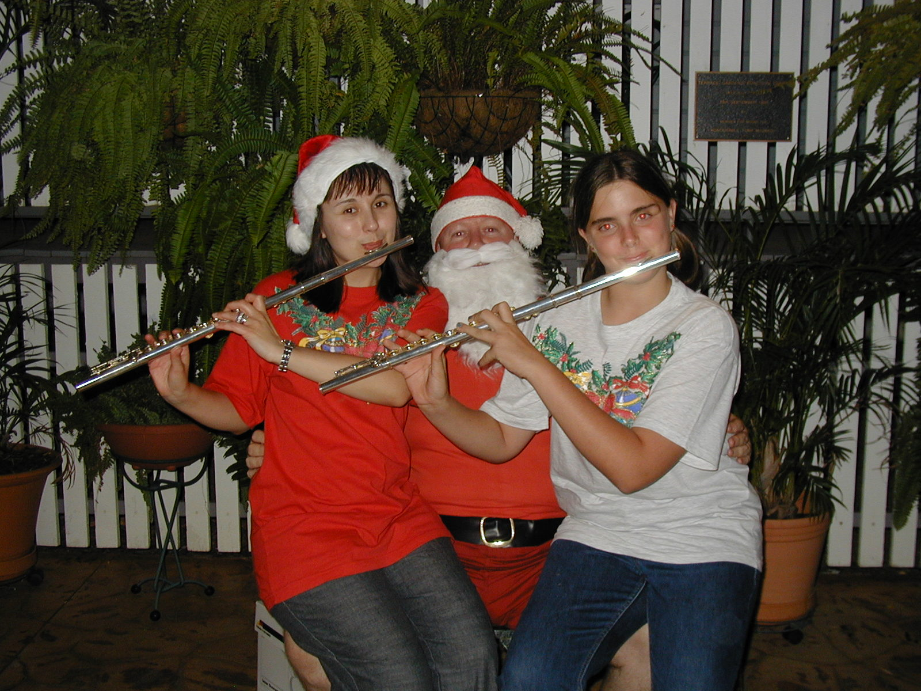

Photo Above: Santa gets a serenade from Kate and Nerida.

Now, the nibbles! Wot can I say! Absolutely fabulous! Sonya and Co. outdid themselves again. It was a feast extraordinaire! (I personally have to thank you for the Oysters Sonya. They worked!)

I’ve dropped a couple of photos in the Newsletter for you to have a look at. Prints will be at the next 2 Meetings for you to peruse.
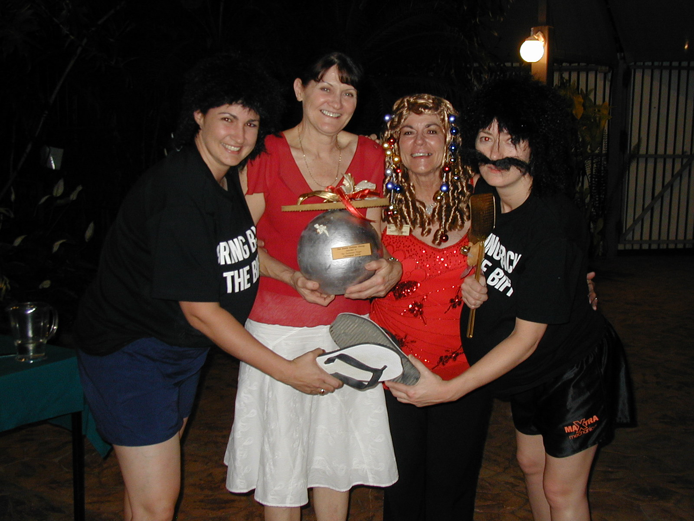
Photo Above: Rosemary with her “Thong Fling” Trophy. Shirley Temple look alike is actually Cherry, and of course the Biff Duo.

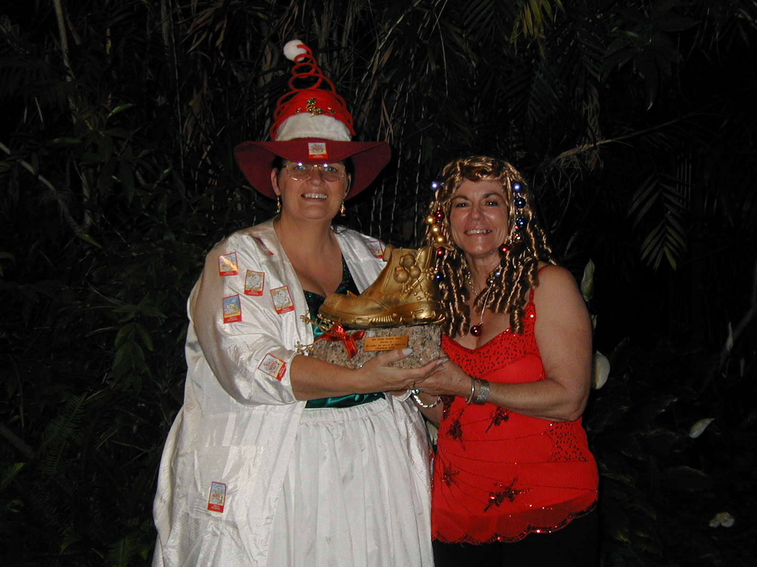Photo Above: Paula (Breaky Club) wins our best dressed Zontian Award. (Note Trophy, wot a bonza, Old boot on Brick. How more Australian can you get?)

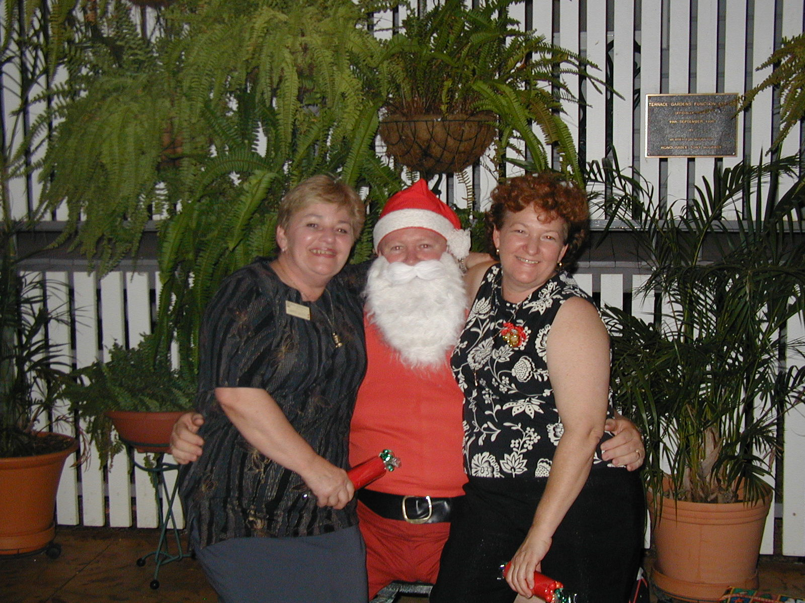
Photo Above: Margot, Santa and Sonya

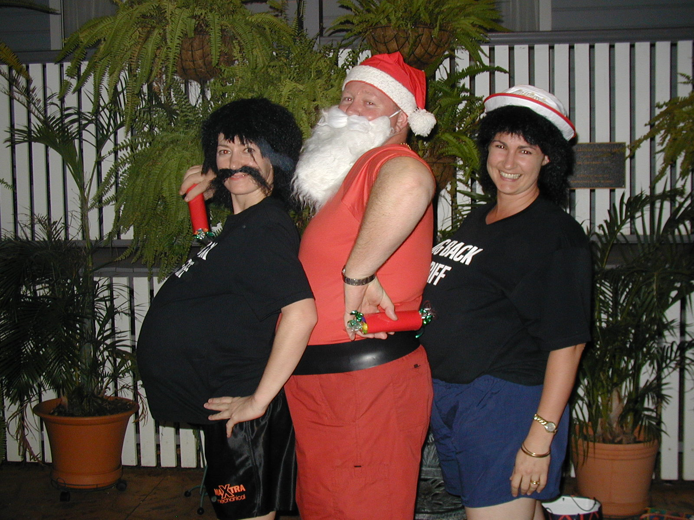
Photo Above: Who’s got the biggest tummy?

I have to stop putting photos in, this’ll never send at this rate. There are sooooo many good photos though.

BIRTHING KITS
Big thank you to the wonderful Zontians who turned up, and made Birthing Kits at my place on Sunday.
It looks like we have a new record “1000 Birthing Kits were made in just under 4 hours”. And, by only 13-15 Zontians.

It wasn’t really hard work, as we gossiped our way through the 4 hours.
Marilyn organised us well, and did more running around on the day than anyone.

It was nice to see our sister Zontians from the Breaky Club there to. A great showing from them.

All who didn’t turn up, you missed out on a top time of fellowship and doing good.
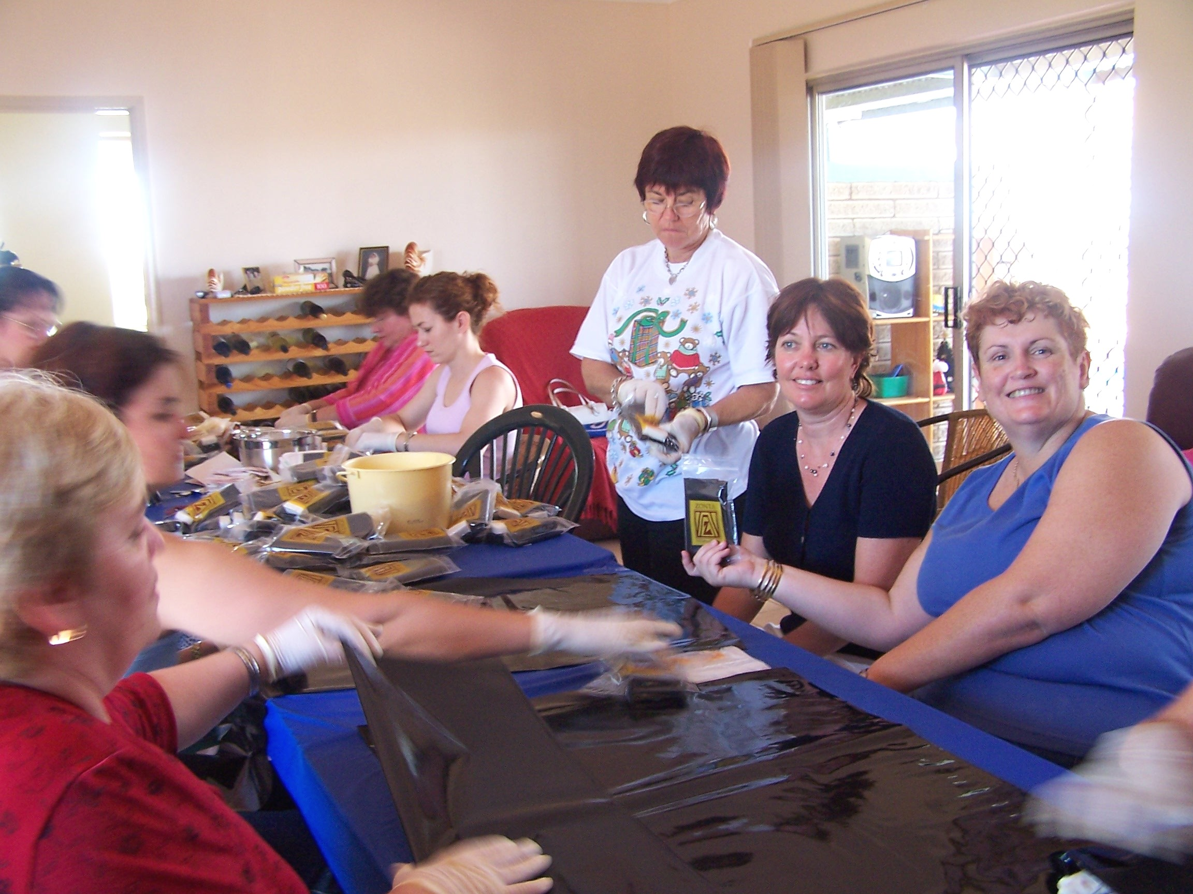
Photo Above: Some of the hot and sweaty workers at Chez Merlin
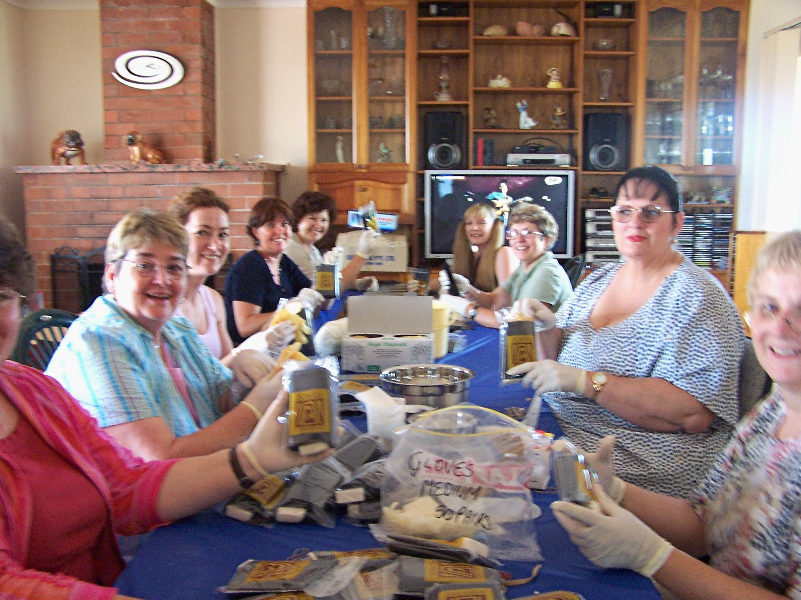
Photo Above: More hot and sweaty workers!

WINE RAFFLE

Well the wine raffle is winding down. Tickets are selling fast. Not sure of exact money banked yet, but I’m sure Nellie will fill us in at December meeting.

SO, TICKETS AND MONEY BACK TO NELLIE BY 13TH DECEMBER – PLEASE!!!!!
Wine raffle will be drawn at the Xmas Meeting at Linda’s Place.

CAROLS BY CANDLELIGHT
We did not make Fairy Floss at Carols by Candlelight. Time escaped moi. I had new carpet going into the Shop, and just could not do all the necessary arranging. (You know, electricity, tables, machine, sugar etc…..)

We also missed out on funding from AMP as we weren’t quick enough off the mark. Look out next year. Big thank you to Cherry and Shannon for trying for us though!

AREA 7 WORKSHOP MEETING
I am having an Committee Meeting at my house (30 Mullan Street) on Monday, 13th December at 6pm.

This is the initial start-up meeting, we will be giving out jobs and doing a lil’ planning. Please come along and get involved. I have your names, all those who said they were interested, but I don’t want to have to use it. Please come along.

DECEMBER MEETING – 15TH DECEMBER
Our December meeting is at Chez MerLin. As Merv and I are catering (on the meat side), please make sure you apologise to Margot by Monday, 13th December.

Failing that, come along and enjoy the view and have a last Festive Zonta Fling for 2004 at Chez Merlin on the 15th.

Cost is still $30 (it’s a fundraiser to send people to District 24 Conference next year). Start time 7pm for 7.30pm.

Also, BYO drinks. I’ll have tea and coffee, but if you want Champers or other stuff, please bring some.

That’s all for now! See you at Chez Merlin.
ZONTA ON!!
Linda Harrison
El Presidente.

OUR BIRTHDAY GIRLS THIS MONTH ARE
Chris Gillic 25th December
Sonja Wessels 26th December
Margot Dunstan 27th December

NEWSLETTER SUBMISSIONS
Any submissions for Newsletter, must be in
5th January
(first Wednesday of every month)
email: kalouclarke@bigpond.com

Thought for the Month

Being myself includes taking risks with myself, taking risks on new behaviour, trying new ways of “being myself”, so that I can see how it is I want to be.
Hugh Prather

January Meeting
Coffee and Cake at Terrace Gardens.
Wednesday, 19th January

The following is an excerpt from Kelly and Patrick Stokes’ Christmas newsletter to family and friends…

Patrick is now working as a Process Engineer for BHPBilliton-owned QNI (Queensland Nickel) nickel refinery, located in Townsville. He seems to be enjoying it, and has said that everyone is really nice to work with. Another perk of the job is that BHPBilliton employees can purchase diamonds at wholesale price! I have scored myself a Refinery Specialist role with Korea Zinc-owned Sun Metals zinc refinery located in Townsville, starting December 6th. I have also met with both of the Townsville Zonta groups, and have become acquainted with some lovely women that I am looking forward to catching up with once a month at the regular meetings.

If you are ever passing through Townsville, stop in and say Hello!
Love,
Kelly and Patrick Stokes
14/2 New England Court
Riverside Gardens 4814
Ph: 4779 6142
patrickstokes@bigpond.com
and kellystokes@bigpond.com

MEMBERS DATABASE – DECEMBER 2004

SURNAME | NAME | BUS PH: | FAX PH: | HOME PH: | MOBILE NO: | EMAIL ADDRESS | COMMITTEE
BROSNAN | CHERRY | 4743 4477 | 4743 4831 | 4743 5362 |  | Big.bros @ bigpond.com | MFO&E – PP 01-03
BURDON | FIONA | 4744 8112 | 4749 0096 |  | 0427 359 342 | Fionab @ hypermax.net.au | S&SOW
CARSON | SUE | 4743 6743 |  | 4743 8117 |  | Barklychallenge @ hotmail.com | PR&C
CLARKE | ALICE | 4743 0261 | 4743 0261 | 4743 0261 | 0438 735 805 | Geotrak @ bigpond.com | S&SOW
COOPER-WARES | LESLIE |  |  |  | 0409 020 844 | Leslie.cooperwares @ bigpond.com | S&SOW
CUNNINGHAM | ANNE | 4749 3411 | 4743 0029 | 4743 3764 | 0471 638 208 | Turangabutch @ bigpond.com | PR&C
DUNSTAN | MARGOT | 4743 5718 | 4743 5718 | 4743 3602 |  | Dunfre2 @ austarnet.com.au | MFO&E – Rec Sec  PP 97-99
FRASER | SARAH | 4745 4444 | 4743 2558 | 4743 1801 |  | Sfras25 @ eq.edu.au | S&SOW
GILLIC | CHRIS | 4743 2577 | 4743 0310 | 4743 2645 | 0427 432 645 | Chrisgillic @ bigpond.com | S&SOW
GLASCO | FREDERIQUE | 4743 3456 | 4749 0151 | 4749 0151 |  | Glascochiro @ bigpond.com | Archives – MFO&E
GRIMALDI | VERA | 4743 4020 | 4743 2257 | 4743 4794 |  |  | FF&P
HANDY | ROSEMARY | 4743 3475 | 4743 7900 | 4743 3121 |  | Account @ obe.com.au | FF&P – Raffles
HARRISON | LINDA | 4743 6733 | 4743 0732 | 4743 0530 | 0419 652 471 | Isaco @ austarnet.com.au | President 03-05
HAY | CAROLYN | 4745 4434 | 4749 0968 | 4743 3163 |  | Carolyn.hay @ bigpond.com | S&SOW – 2nd VP
JACOB | MARILYN | 4743 4449 | 4743 1157 | 4749 2349 | 0408 737 420 | Jacob45 @ bigpond.com.au | CHAIR S&SOW
JOHNSTONE | MARIA | 4743 2365 | 4743 7773 | 4743 6757 | 0413 731 165 | Maria.johnstone @ buffs.com.au | FF&P – Vice Treas
KINGSLEY | SAM | 4149 3838 | 4749 1001 | 4743 5430 | 0438 892 869 | Samax1 @ bigpond.net.au | S&SOW
LARRAZABAL | KATE |  |  | 4743 9552 |  | Kalouclarke @ bigpond.com | PR&C – Nletter Ed
MANNERS | CATHY | 4749 3060 |  |  |  | Cathymanners @ bigpond.com | S&SOW
MEDLEY | MARGARET | 4743 4843 | 4743 4813 | 4743 3853 | 0417 770 393 | Mmedley @ austarnet.com.au | FF&P – Treasurer
MOORE | LEONIE | 4744 4416 |  |  | 0428 759 432 | Leonie_moore @ health.qld.gov.au | S&SOW – Co-chair
PENGO | RHONDA | 4743 5911 | 4743 7035 | 4743 3225 |  | Mountisa @ ljh.com.au | S&SOW
ROSS | VAL | 4743 7727 | 4749 1631 | 4743 7727 |  | Dougval @ netspace.net.au | FF&P
RYAN | LIZ | 4749 3899 | 4749 2799 | 4749 0009 | 0417 770 810 | Mtisapanelandpaint @ bigpond.com | PR&C – Database
SAVOYE | MICHELE | 4743 3642 |  | 4743 5832 |  | Espro @ bigpond.com | MFO&E Chair – 1st VP
SCARSI | NELLIE | 4743 4803 | 4743 9246 | 4743 7977 |  | Etsisa @ bigpond.com | FF&P Chair
SLATCHER | SHELLEY | 0415 923 596 |  | 0415 923 596 | 0415 923 596 | Shelleyslatcher @ hotmail.com.au | S&SOW
STOKES | KELLY |  |  |  | 0402 260 294 |  | FF&P
SWEENEY | MAUREEN | 4743 8857 | 4743 2744 | 4743 8857 |  | Sweeney @ austarnet.com.au | S&SOW
WARD | SHANNON | 4743 4477 | 4743 9493 | 4743 4831 | 0403 376 557 | Shannon_ward @ bigpond.com | FF&P – Co-Chair
WESSELS | SONJA | 4743 6144 | 4743 3250 | 4743 6144 |  | Terracegardens @ bigpond.com | PR&C Chair
WILBURN | DEE | 4743 6616 | 4743 4871 | 4749 0771 |  | Dwilburn @ rfdsqld.com.au | FF&P

ANY ERRORS IN ABOVE DATABASE, PLEASE ADVISE LINDA AND SONJA!
WE NEED YOUR EMAIL ADDRESS TO SEND N/LETTER TO!!!

