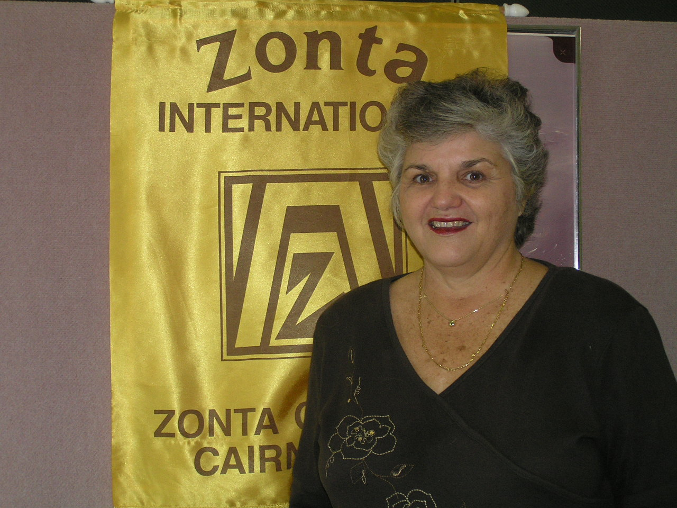

PRESIDENTS NEWSLETTER

Well Melbourne is over and what spectacle it was. To be in a group of 2,000 members of the Zonta community coming from 1,000 professional backgrounds and representing 63 countries was quite a sight to see.

Those members from countries that have wonderful colourful and intricate national costume worn them with pride and dignity. Large groups from Japan, Thailand and the Philippines were softly coloured and a complete contract to those some Niger, Togo and other African countries whose colours were bright yellow and reds and greens. I can only say that because of Australia's large multi-cultural population we will never have a national dress but we are lucky to be able to accept and share such a broad mix of cultures.

The guest speakers were once again inspiring all the way down from the Convention Speaker, Dame Silvia Cartwright, Governor General of NZ, to the three Zonta International Awardees. Profile of these three bright young women are attached. After attending the workshops offered I realized just how fortunate that we are to live in such a country which such freedom of speech, religion and such a high level of personal safety and living standard.

Some of the members gathered with the international Zontians at Palm Cove for a pre-convention meet. From the feed back that we got at Convention we knew that we were in for a bigger night at the post meet. Most internationals (about 60 in all) were really appreciative of our efforts to meet with them and I know there has been several expression from them to return to FNQ. Thank you to our members who joined them and to the committee for their organization of these nights.

Regrettably our foray into Convention Shop did not prove to be the wonderful success that we had hoped and we have quite a bit of stock to sell. Fortunately the art works and scarves are on consignment so we can return unsold stock. We have had to purchase the tea and coffee, and chocolate coated beans but we are confident that some of the members will take some of these at cost price. They make great gifts………

I would like to thank my three traveling partners for their commitment to Zonta Cairns and for the fellowship and laughter we had over several bottles of red wine.

Now down to business. Strawberries & Cream is now on our doorstep and we certainly have some final arrangements to put in place this coming meeting. If you have anything that has to be bought for S&C please, please bring it to this meeting so that we can collate everything that is needed. With fewer members this year the work load will probably need to be a little heavier than in the past but I am sure that we can rise to the occasion and again make this a great fund raising event or the Club.

ALSO WE HAVING ANOTHER BOOK NIGHT……. SO PLEASE BRING BOOK ETC FOR SALE………..

Yours in fellowship through Zonta.

Lale M. Jones

Apologies: All apologies for non-attendance for the Dinner Meeting To be ‘phoned through to Lorraine on 4031-7400 by
Friday, 7th July at 5.00 p.m.

DIARY DATES

11th July Dinner meeting – Sheridan Plaza
Another Book & CD sale –so bring along your books /Cds

18th July Board Meeting – Yumi Smith’s

19th-21st July Strawberries & Cream- Cairns Show
1st August Dinner meeting- Sheridan Plaza

15th August Board Meeting- Yumi Smiths

COMMITTEE MEETING MINUTES

Finance Fundraising and United Nations

No report received at time of printing.

Organisation Classification & Membership
The meeting took place at the Corp.Towers Coffee Shop on 15/06/2006 at 7.30am.
Present; Avril Bulstrode, Anne St.Martin, Glennis Webb, Paivi Pratley.

There will be an induction of a new member Janet Liu Terry t the next dinner meeting on the 11th July. Anne St.Martin to organize badge, manual and Zonta Stick Pin. Avril will organize the yellow rose. Anne will ask Janet for a short biography to present at the dinner meeting .Glennis Webb and Anne St.Martin will meet with Janet to inform her about what Zonta is all about. Ann to fill out Prospective form for visitor Joy Clarke to be faxed to Board member Avril Bulstrode and presented to the next board meeting. On Wednesday 21st June the pre –convention cocktail party will be held at Stinger’s restaurant in Palm Cove from 6.00- 7.00pm. Avril has organized platters to be passed around by Zontian members. As the above date 15/06/2006 there were only 20 responses for the pre –convention gathering and no responses fro the post – convention cocktail party which will be held on July 5th at the same restaurant. At the cocktail party we will set up a table and give each delegate a name label and yellow rose. The members will have to buy their own drinks. Judy Noller, a new Zonta member will need a mentor to oversea and explain the Zontian ideals and what is expected from her. (Anne St.Martin, Chair)

Public Relations & Communications.

Minutes of meeting held at Tower Coffee shop Wednesday 14th June at 7.30am.

Present: Anne G, Jan & Lorraine
Apologies: Yumi, Valerie & Julie J (LofA)
and Lorraine

Post mortem on movie night, committee happy with newspaper, radio and TV coverage. Thought that consideration could be given fro Zontians paying $10/$15 towards pizzas instead of finger food (depending on tickets sold and Zontians in club) serving Potato chips with 1st drink then bringing out Pizzas- Pics n’Pizza. Only allow 30mins prior to movie, as regular guests come early anyway.
Breast care posters have been distributed to Zontians need to be delivered to hospitals and Cancer fund. Reminder to committee of pre and post convention tours. Still no “Greatest Asset board "or photos for web page. Lale to follow up with Helga. Suggested ways to promote Zonta, as advertising is not an option. Anne G has contacted the CPA re signage at Airport. Suggested that Zontians could all donate blood at Red Cross, say Friday before S&C stall, and organise Cairns Post/Sun for a photo shoot and we could advertise S&C, and our fundraising for Harold’s House, take idea to Dinner meeting.
Next meeting 12th July at Tower Coffee Shop.
Meeting closed at 8.20am

Status of Women.
No report received at time of printing

Quote for the Month

Confidence comes from doing the Best that we can- Not from being PERFECT.

GOODIES BASKET

Remember to bring along any donation of personal items to the next dinner meeting for Ruth’s women’s shelter.

Birthday Babe’s Best wishes to:
Julie Abrahans 7th
Anne St. Martin 16th
Sally Graham 28th

Members Snippets
Welcome back to Valerie, and Wendy.
Farewell to Avril- off to the UK and USA for 9 weeks.
Farwell to Janella -off to windy Perth

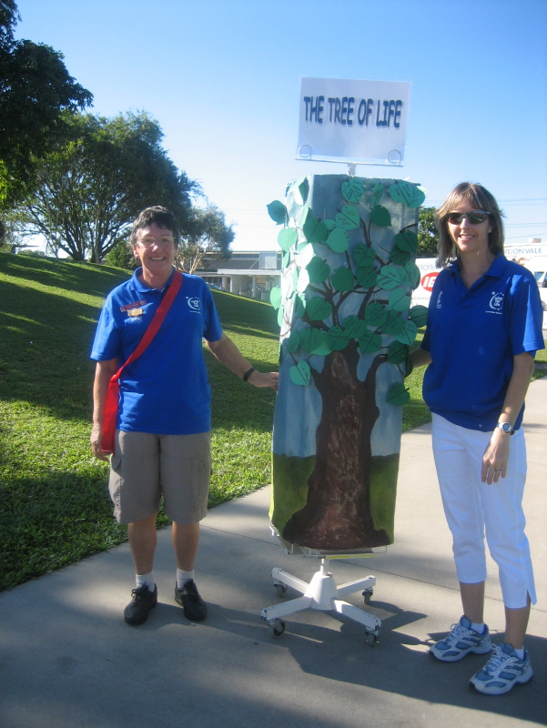

Sally Graham with the “ Tree of Life “ at Relay for life

Newsletter articles

If possible please submit all newsletter contributions as a word document attached to your email to janigg@iig.com.au. This would be greatly appreciated. Please note Jan’s new Fax number 40547697.

PRE/POST CONVENTION HAPPENINGS

Well we certainly have been meeting Zontians from far and wide. Firstly Margaret Bruce from Sth Brisbane, Diana Douglas from Toowoomba. Debbie ,Janelle, Suzanne and Anne G met for drinks / dinner with a Texas Zontian Lyn whilst she was in Cairns prior to the convention. Along with 29 Zontians, from the USA, Sweden, Austria, Japan and many more at the pre convention tour at Stingers at Palm Cove

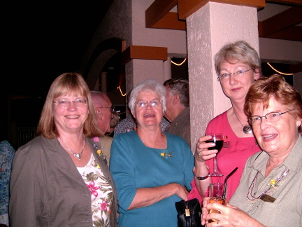

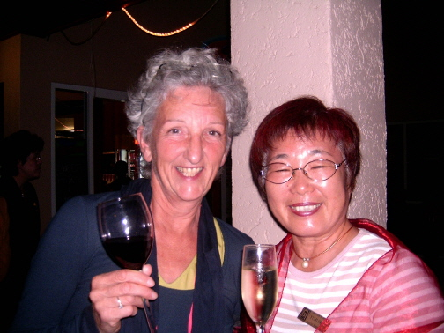

Above - Zontians gather at Stingers – Palm Cove post convention for fellowship.

BOOK & CD SALE 11th July Dinner meeting

To explain this evening for our newer members - simply donate any books, or CDs to the dinner meeting on the 11th July, all proceeds of sales at $3.00 each goes towards our Literacy Award.

