

EMAIL- southerngoldcoasttweed@zonta district24.ogg

.
Correspondence/Newsletter: Merle Stephen (H: 55980409 Email libra@qld.chariot.au)

DATES TO REMEMBER

20th February DINNER MEETING
8th March 2006 INTERNATIONAL WOMENS DAY BREAKFAST
12th March AREA MEETING
14-29 JUNE 2006 INTERNATIONAL CONVENTION MELBOURNE

DINNER MEETING DETAILS

MONDAY 20th FEBRUARY 2006 RAINBOW BAY ROOM
GREENMOUNT RESORT COOLANGATTA

6 – 30 FELLOWSHIP, MEETING STARTS 7 P.M.
APOLOGIES MERLE STEPHEN 7pm 16th

FAILURE TO DO SO MEANS YOU WILL BE CHARGED FOR DINNER

ZONTA BIRTHDAY - ROBYN

THOUGHT OF THE MONTH

Go confidently in the direction of your dreams!
Live the life you have imagined.

Henry David Thoreau, 1817-1862

PRESIDENT’S MESSAGE

Once again we are hard at it with our International Women’s Day Breakfast just around the corner. The IWD Committee have been busy behind the scenes, ensuring that all arrangements are in place for the breakfast.

At our last meeting it was great to see everyone assisting with the enveloping of the invitations. I would also like you to put aside Saturday the 25th February, when everyone’s assistance will be needed for the “Bag Stuffing Day” to be held at Merle’s place. This is placing all the brochures etc into sample bags ready for the 8th March.

Your assistance will be required also on the evening of the 7th March for setting up for the breakfast, as well as EARLY on the 8th for final preparations, and to carry out your allotted jobs for the day. So keep these dates open in your busy diaries.

Also make sure you have your replies in early, as first in get the best seats, and don’t forget to bring along to the next meeting any raffle prizes you have managed to acquire.

Once we have this event over, we will be having guest speakers at our dinner meetings, so if you have any suggestions, please let them be known at the next meeting.

Just to keep you on your toes, don’t forget we have the Area Workshop on the 12th March, which is a great way to learn more about Zonta and to meet new Zontians.

See you Monday night.
LESLEY

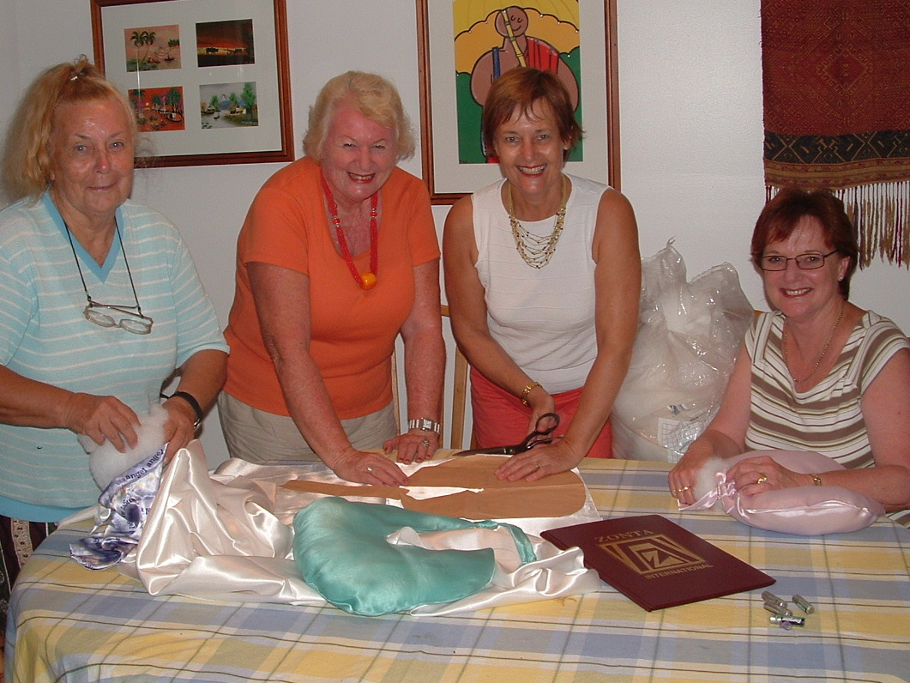

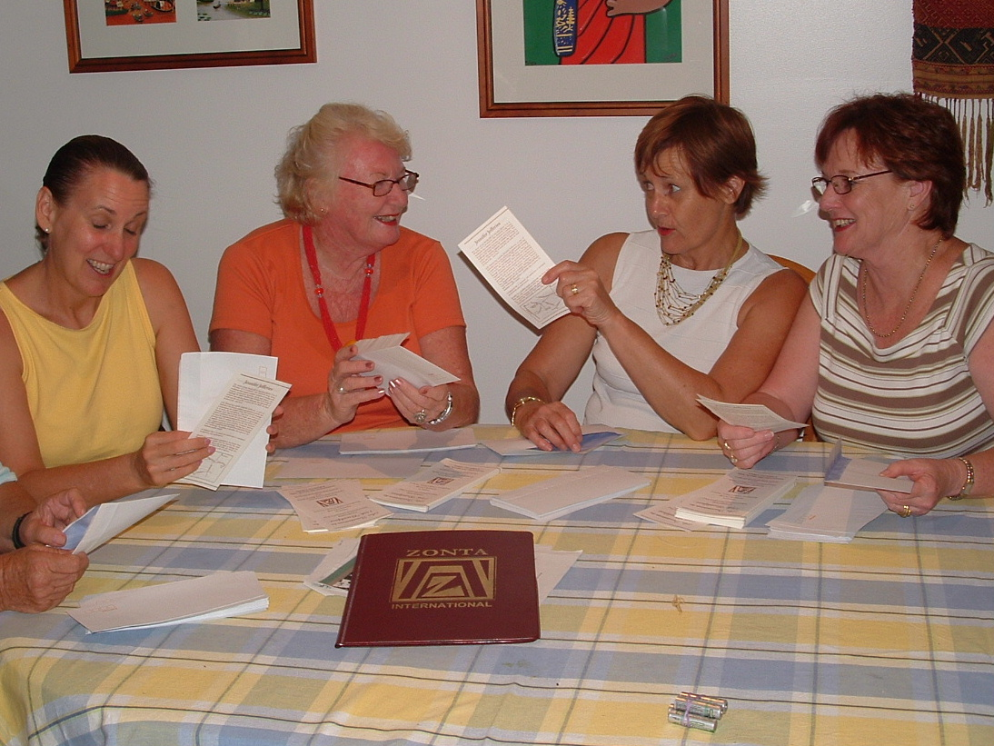

ZONTIONS AT WORK

EDITORS NOTE
I have to report the sad news that Helen passed away, our love and sympathy to Janet and family. Lesley and I represented the club at the funeral.
Dinner will be served at 7pm, during daylight saving, for the benefit of our N.S.W. members, please be on time.
Don’t forget to let me know if you cannot attend meetings .

Merle

