‘THE WHISPER’
Official Newsletter of Bowen Zonta Club Inc.
District 24 Area 7 Club 1476 Volume 1 Number 1 May 2004

WHAT’S HAPPENING

HANDOVER DINNER
Celebrating 10 years in Bowen!
Saturday 5th June
Castle Motor Lodge
at 6.30 for 7.00pm
Delicious 2-course dinner,
lucky door prize,
cost $30 per person.
RSVP Essential to
Julie Jurgens 47861418 (ph/fax)
not later than Monday 31st May.

Guest Speaker: Sally Abbott
Remember partners and guest are welcome.


BIRTHDAYS
Best wishes to the following girls

Karole Bayldon 1st June

Laraine Smith 12th June
and
Lynette Klukas 26th June

CONTACTS
President
Laraine Smith
4785 1230
laraine.smith@bowenshs.qld.edu.au
Treasurer
Maxine Todd
4785 2236
gmttomatoes@bigpond.com
Secretary
Lara Finlayson
4786 2368
0414 847 538
bpools@tpg.com.au

NEXT MEETING

Wednesday 9th June
7pm Castle Motor Lodge

Apologies to
Lara Finlayson
4786 2368
0414 847 538

  News Snippets
Bridesmaid says Mary's in good hands
Sarah Grant
28 May 04
NOT even a prince can detract from the loyalty and depth of a 10-year friendship.
Amber Petty, 32, from Sydney, who joined Mary Donaldson's sisters as bridesmaids in the royal wedding, yesterday spoke of the confidence she has in her best friend's marriage to Crown Prince Frederik of Denmark.
While describing the three weeks she spent in Copenhagen as a dream, Ms Petty said Mary's newfound stature as a princess would not challenge the bond the two women formed 10 years ago as work colleagues in Melbourne.
"To have the experience of being Mary's bridesmaid was a special highlight of the wonderful friendship we have, and I know our relationship will always remain the same," she said.
"I guess that's because Mary hasn't changed since she met Frederik, she's the same down-to-earth girl with the same values and attitude to life."
Ms Petty, a Pacific Publications marketing manager and budding MTV reporter, had recently spoken to her best friend during her honeymoon in Tanzania -- a surprise gift from Prince Frederik -- and reported the royal couple were having a wonderful time.
Ms Petty's role made her an overnight celebrity. To her amusement, she was linked to a German prince she had never met.
Ms Petty has spent ample time with her best friend's distinguished husband since they met in Sydney four years ago.
"He's just gorgeous -- he made everyone cry at the wedding. It's such a great feeling to know that she is marrying someone that I now call a friend, I know she's in very good hands."
Nothing to do with me, I'm just a victim of my genes
ANNA SMYTH
The Scotsman - May 26, 2004
IT’S OFFICIAL, it’s not your fault. Having a bad hair day can be explained away with genetics, thanks to some very kind men in white coats. Researchers studying mice in Washington have determined that the aptly-named gene "frizzled 6" controls hair patterns. Subjects without the gene had strange patterns, including whorls of hair on their hind feet, back of the head and chest. Some also had tufts and ridges in the hair on their head. As humans have an almost identical version of the gene, they suspect that we can similarly blame genes for our bad hair days.
The downside is that there is no way to reverse this deficiency. Yet Jeremy Nathans, who headed up the team at the Johns Hopkins School of Medicine, believes the phenomenon is a bonus - "these are the things that make life interesting," he said. Tell that to Donald Trump. But perhaps there are other such genes we don’t yet know about ...
THE NOTHING TO WEAR GENE
Admittedly it does defy logic, but it is an undeniable fact that every Saturday night a staggering proportion of women stand amid an ocean of designer garments, tearful at the realisation they have nothing to wear.
The NTW gene could easily eradicate the worst element of this problem - the unsympathetic partners. Be it a boyfriend, wife or flatmate, the spectator of this catastrophe should avoid at all costs the temptation to reply: "What on earth are you talking about? You’re surrounded by suitable ensembles" Instead, they could say: "Well, I suppose that is your mother’s fault, passing on such a deficiency, but why don’t you try that little red number that always makes you look fabulous." It’s perfect. Men like reason, women like getting off scot-free. Get a boffin on the case quick-smart.
THE OOH I’LL JUST HAVE ANOTHER SLICE OF CAKE PLEASE GENE
Temptation is a wonderfully cruel thing. There you are, faced with a delectable cream cake, and somebody somewhere expects you only to take just one slice. Sorry, no can do.
But if this insurmountable weakness could be linked to your DNA, what a happy little world this would be. There would be no more guilt-ridden afternoons, hours spent regretting that over-indulgence. No, the one more slice gene would provide us with a shameless excuse to tuck in - we simply wouldn’t have the biological material to stop the frenzied feeding.
Far better than the usual, "I have glandular issues", you could actually win some people over by blinding them with geneticist lingo.

Letters to the Editor 
Ladies
What! No news or gossip? I don’t belief it. Please. Any items of interest you wish published, write to the editor or email your info, we want an entertaining and informative newsletter.
The Editor
Bowen Zonta Club Newsletter
PO Box 1023
BOWEN QLD 4805

Email: dympian.lee@bigpond.com
QUOTES OF THE MONTH
“Common sense is not very common.”

Women in Profile
No one was nominated at our last meeting – but I would like to nominate one of our newer members and soon to be Attendance Committee Chair: Angela Cornwell. Angela, if you could have your profile to me by end of June that would be great. Rhonda

   

Women’s Symposium
The women’s symposium was held at Proserpine on the 15th May with a good attendance from Bowen ladies.
The speakers were top class and it was a great day for all who attended. Great to see such good support.

May Workshop
As everyone has heard Bowen hosted a very successful workshop. The following was printed in the Burdekin Zonta Newsletter: “One of the best workshops she has been to. Now that is a big call
Words spoken by District Governor Robyn Gaspari from Sydney regarding the Bowen Workshop.
and the article continues:
“Bowen members were very welcoming and Cheryl Vennard did a wonderful job as chair for the weekend. Saturday consisted of the afternoon only and we convened back to the front of the motel at 5.30pm to join the bus for a tour of the beaches, ending atop Flagstaff for drinks and nibbles. The setting is just superb with views of nighttime Bowen very picturesque. The daytime view from Flagstaff is beautiful also and well worth a drive up there if you are in the area. We were then bussed back to the motel for a delicious meal, listened to a very interesting speaker (Ann McQueen) as well as our own Burdekin and Bowen Presidents who then cut the 10 year birthday cake.
Events became a little different from that point on with one of the Presidents having injured herself and requiring a trip to the local hospital. It was rather convenient that our guest speaker is the lady in charge of the Bowen District Hospital nursing staff. She phoned through to the sister in charge and organized for the doctor to be at the hospital when the injured president arrived. Alls well that ends well and the president is now recovering with a broken bone in the right hand.
Sunday got off to a good start at 9.00am ish and was full on until 4.45 pm ish. It was a hands on workshop with good speakers, good workshopping and good ideas coming out of the discussions. Those lucky enough to stay enjoyed a bbq at Mullers Lagoon that night which I am sure was a great social event with all Bowen ladies being able to finally relax.
55 ladies attended from both Mt Isa Clubs, Townsville, Whitsundays, Mackay and 6 from the Burdekin. Our newest club, Charters Towers had 3 ladies there on Sunday and it was nice to meet these new young Zontians. The loveliest part of these workshops is catching up with Zontians from the other clubs who we meet each year. Our new area 7 Director Libby Gleeson from Townsville will take over from Majella in July. No doubt Libby will announce in due course where the next workshop will be. We all look forward to working with Libby and thank Majella sincerely for the time she has put into being Area 7 Director. It requires dedication to the clubs, the district board and involves a lot of travelling. Thank you Majella.”
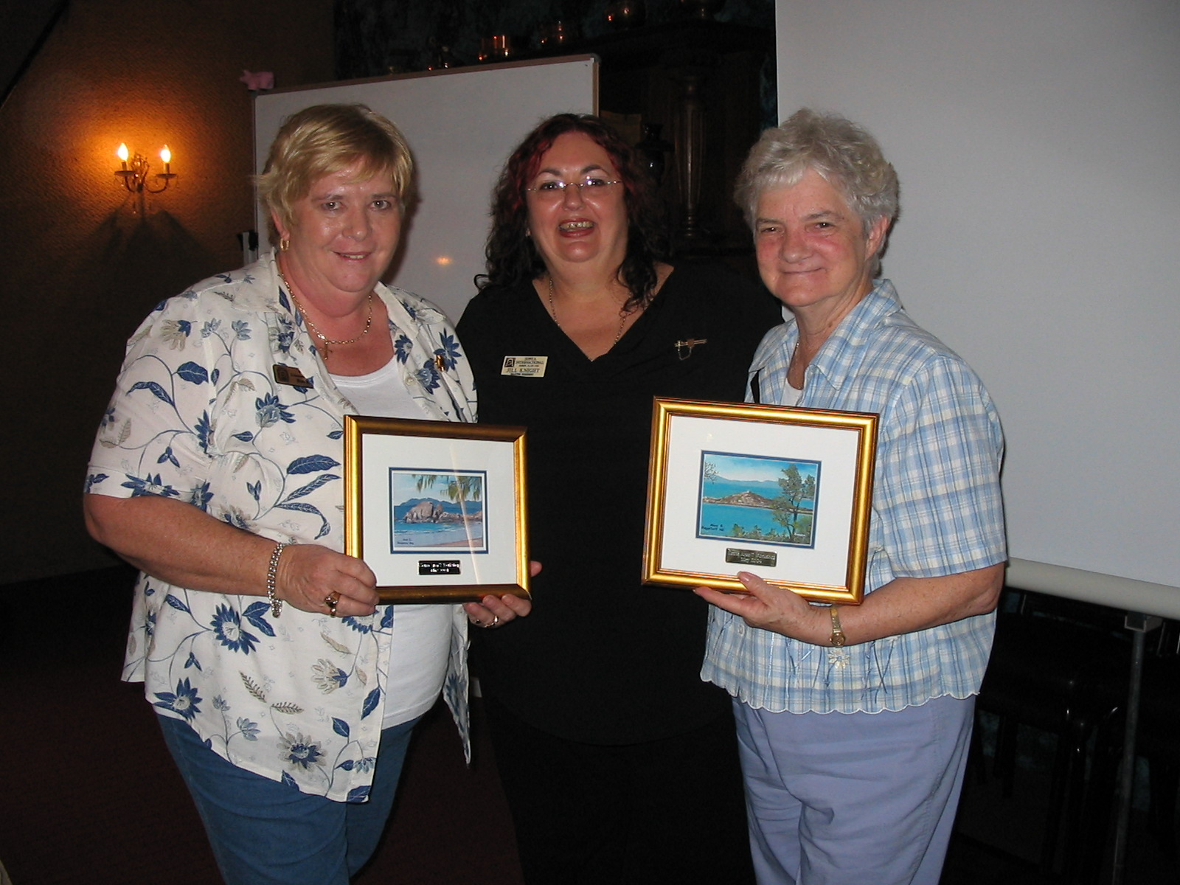

Jill making presentation of Bowen Landscape to Ros Kinder & Robyn Gaspari

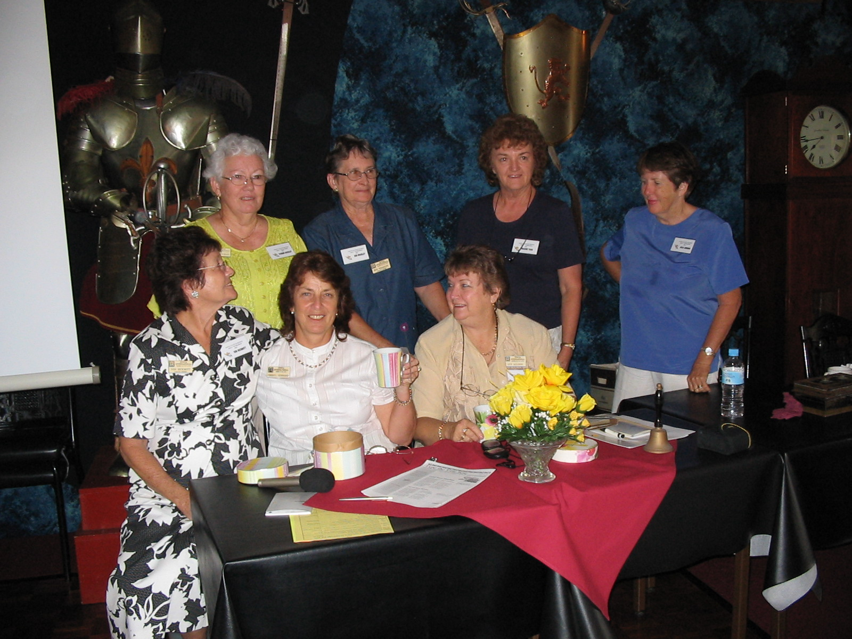

Organising Committee for the Workshop

OJECTS OF ZONTA INTERNATIONAL
- To provide service at the global and local level.
- To improve the legal, political, economic, educational, health and professional status of women
- To work for the advancement of understanding, goodwill, and peace through a world fellowship of executives in business and the professions.
- To promote justice and universal respect for human rights and fundamental freedoms.
- To be united internationally, to foster high ethical standards, to implement service programmes, and to provide mutual support and fellowship for members who serve their communities, their nation and the universe.

Committee Chairs for 2004/2005
Finance & Fundraising Betty Ann Wright
Membership & Classification Lyn Allison
Status of Women, Service Rhonda Nilsson
Program Cheryl Vennard
Communication & PR Linda Tickle
Attendance Angela Cornwell
Archives Janice Pearce
United Nations Von Hickmott
Raffles Melda James
Nominating Committee Jill Knight
Karole Bayldon
Cheryl Vennard
Newsletter Rhonda Nilsson

DON’T FORGET handover dinner 5th June

The views expressed in this newsletter are not necessarily those of Zonta International

